Flower Girl Seeks Family

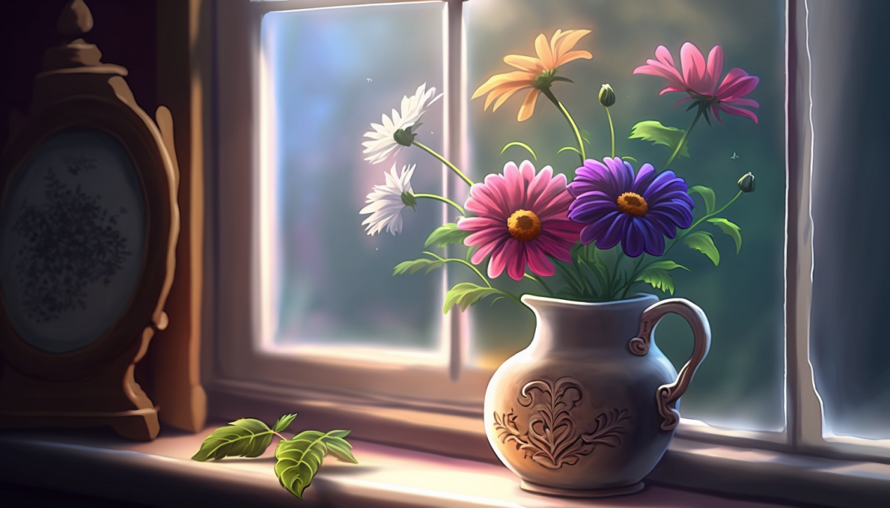

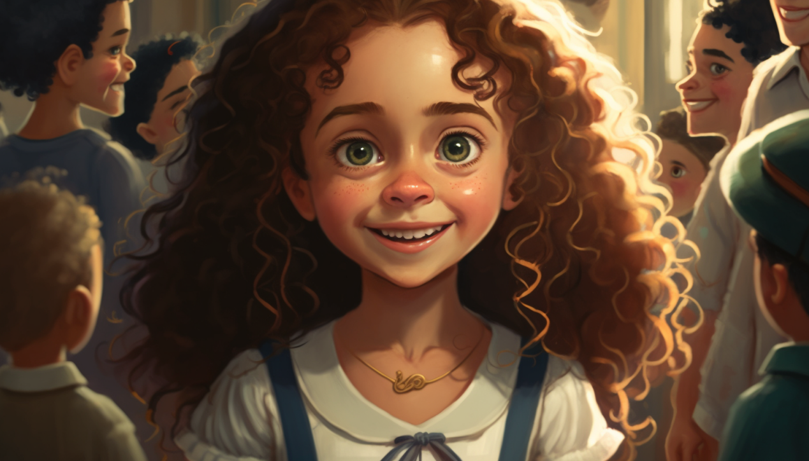

Once upon a time, there was a small girl named Lily. She had long, curly hair and big brown eyes that sparkled in the sun. 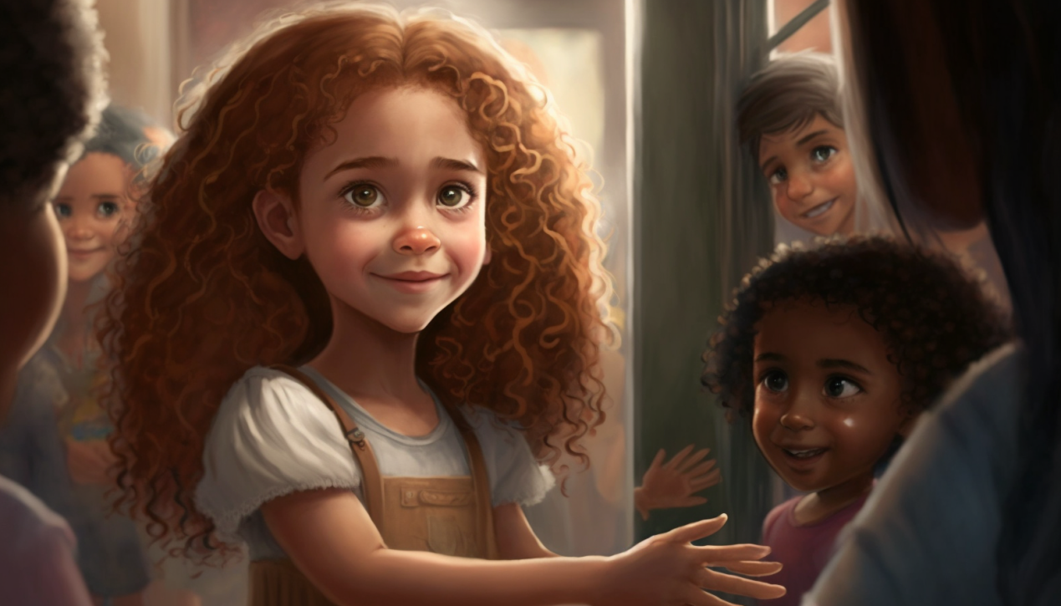

Lily lived in an orphanage with many other children, but she always felt a little bit lonely. However, she had a pretty flower that she treasured, and all she wanted was to give it to someone she loved.

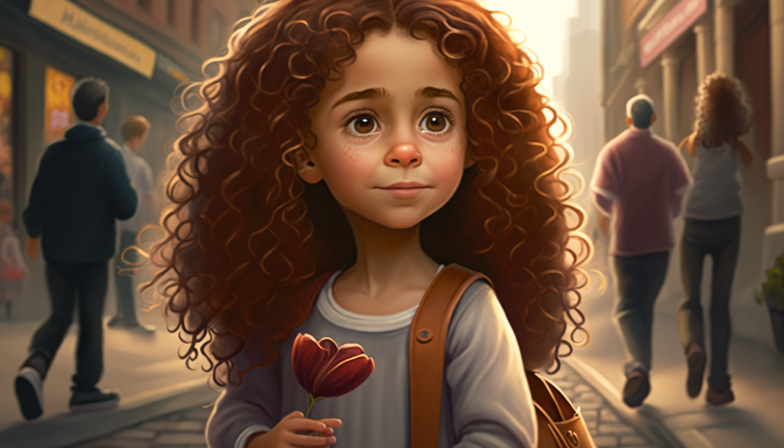

One day, Lily was walking down the street, holding her flower tightly. She saw an old lady walking towards her, and without hesitation, she walked up to her and held out her flower.

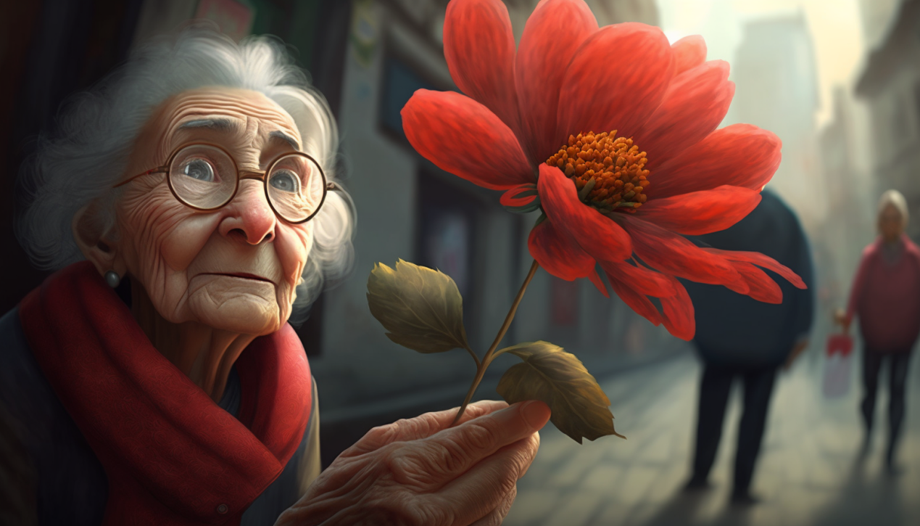

The old lady smiled and patted her head, "That's a beautiful flower, dear. But you should keep it. It will make you happy."

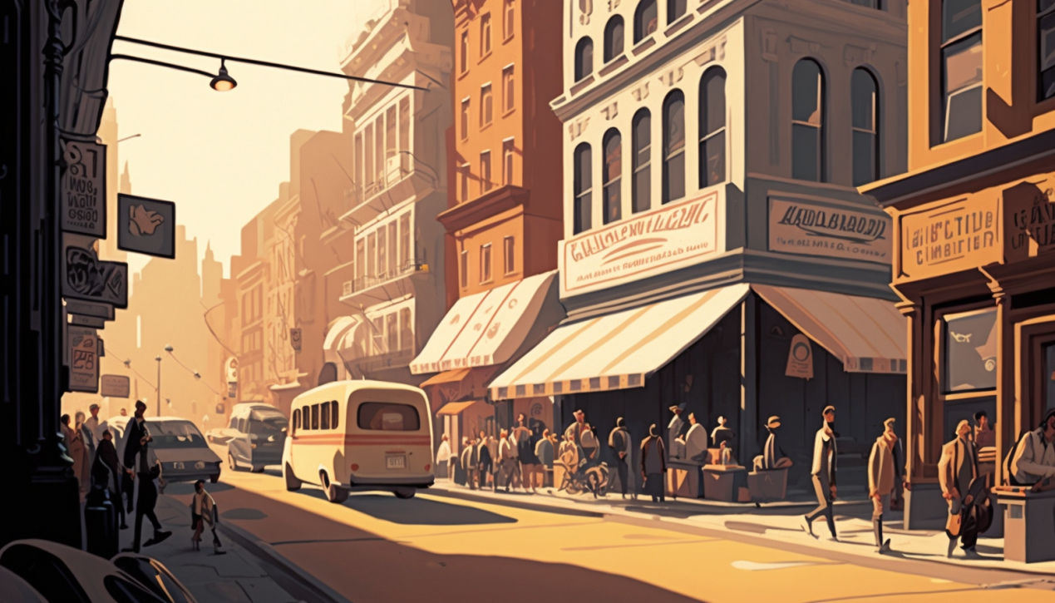

Lily smiled at the old lady and kept walking, feeling a little bit disappointed. She wanted to give her flower away, but the old lady didn't want it.

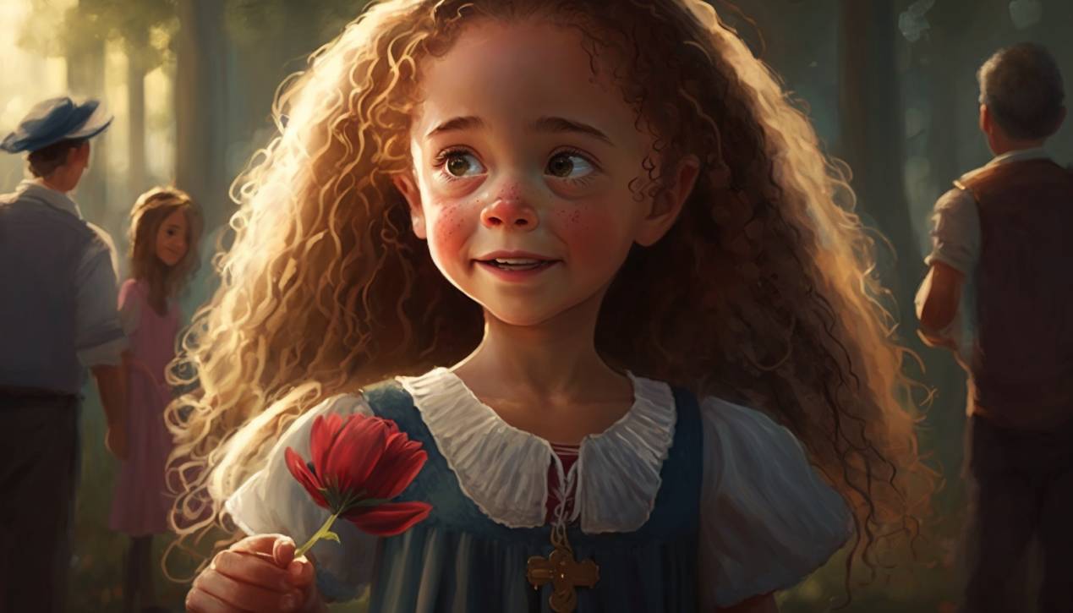

As she continued walking, Lily saw a little boy sitting on a bench, crying his eyes out.

Without hesitation, she walked up to him and held out her flower. "Don't cry," she said softly. "Take this flower. It will make you feel better."

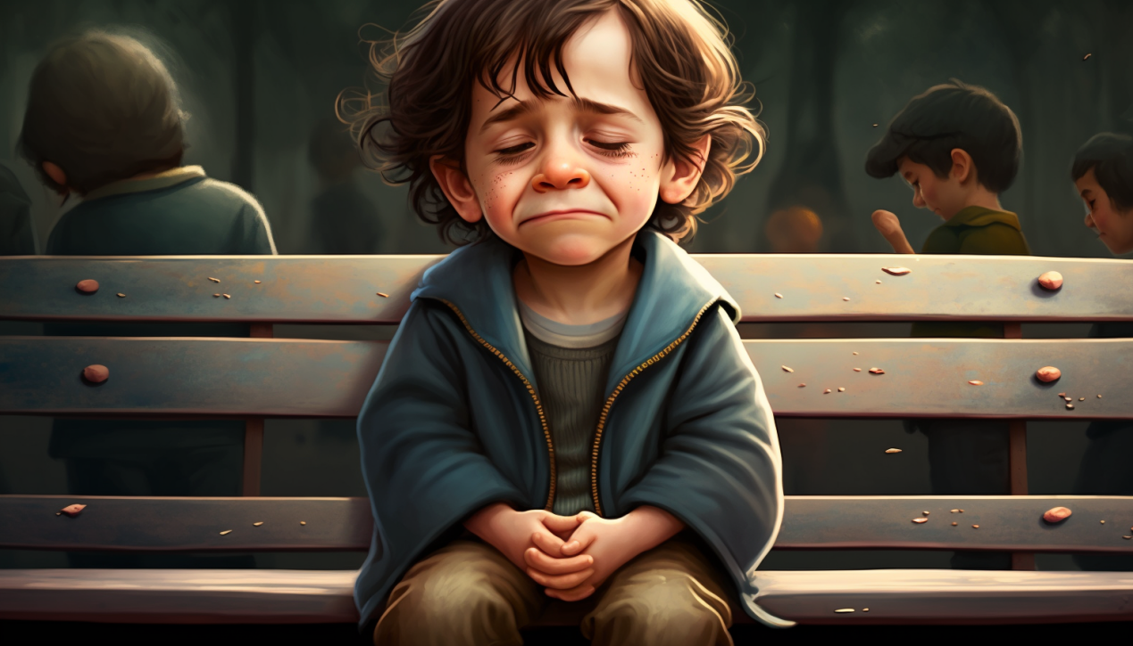

The little boy stopped crying for a moment, but then he started again. He looked at Lily and said, "I don't want your stupid flower. I just want my mommy." And with that, he continued to cry.

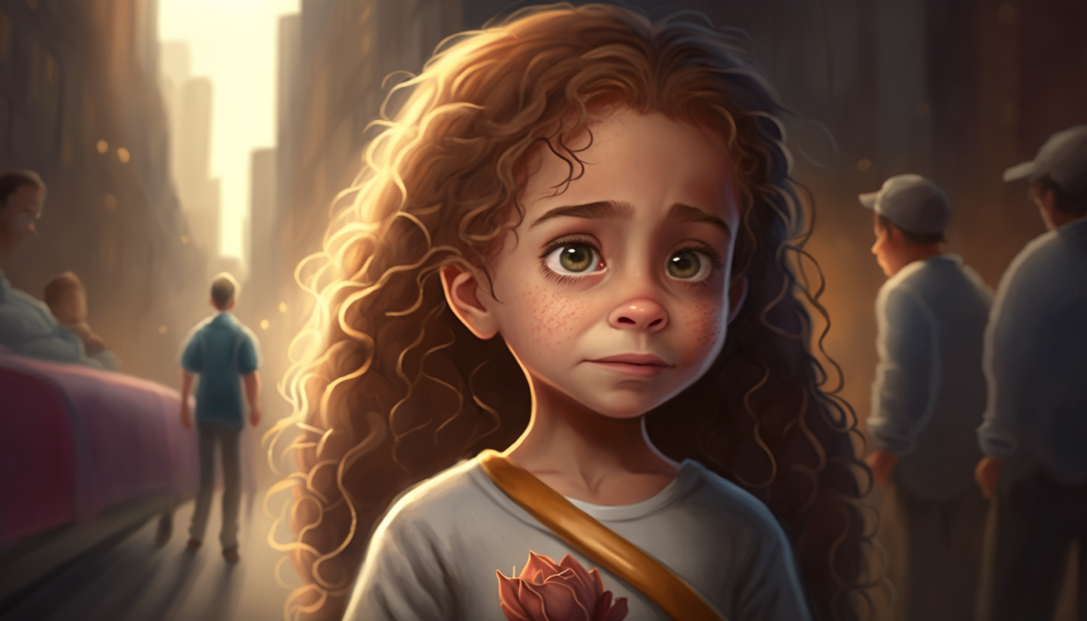

Lily's smile began to waver as she thought about how she just couldn't seem to give her flower away. She started to feel a little bit discouraged and wished she had someone to talk to.

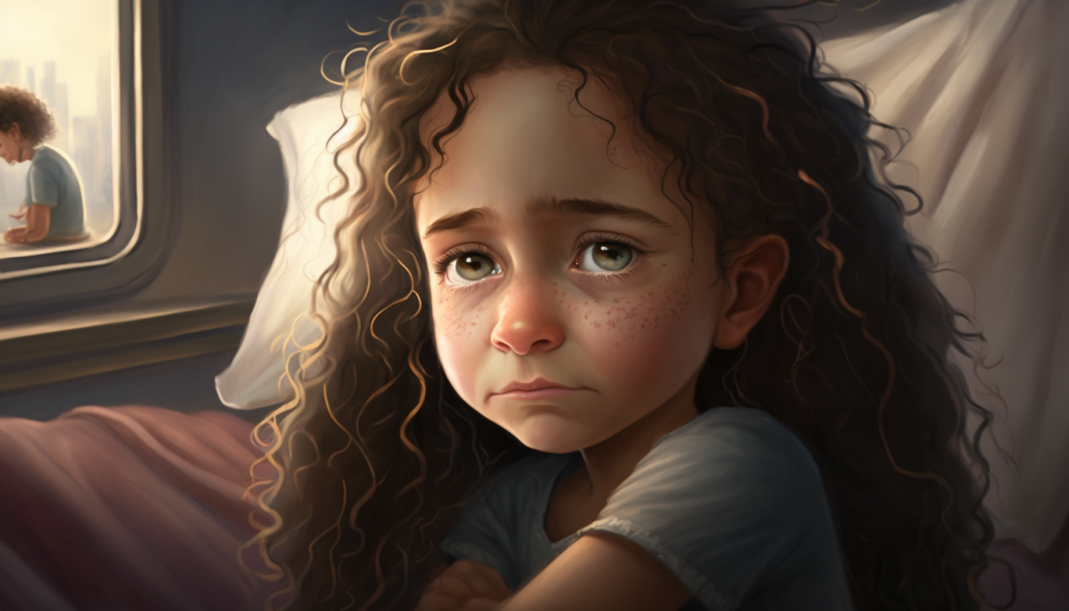

Finally, Lily arrived back at the orphanage. She walked into her room, sat down on her bed, and looked at her flower. She loved it so much, but she just couldn't seem to find anyone to give it to.

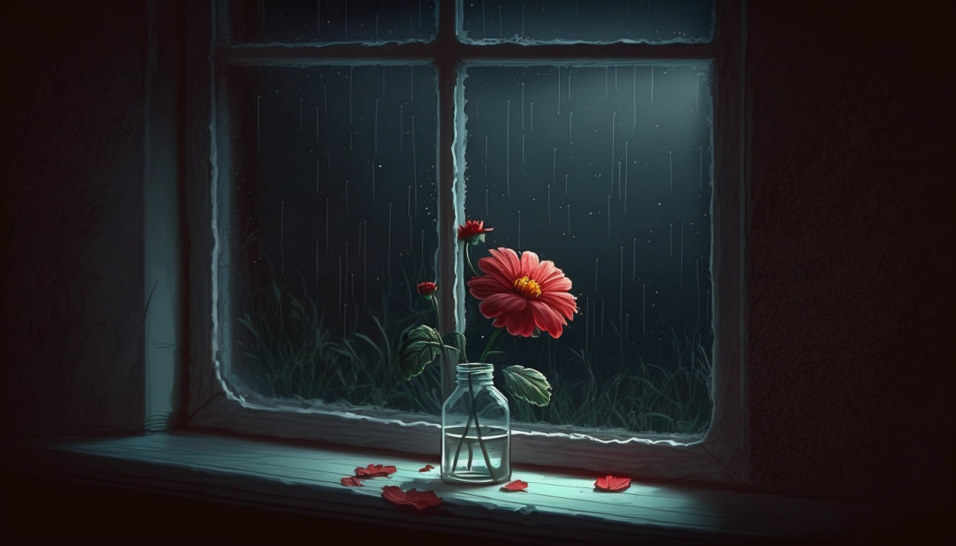

That night, as she lay in bed, Lily began to cry. She wanted a family more than anything in the world. She wanted someone to love and someone to love her back.

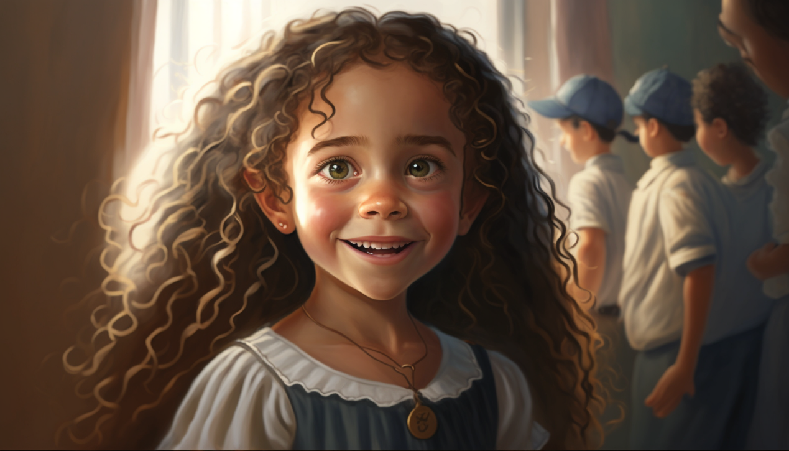

The next day, Lily woke up feeling a little bit better. She decided to take her flower with her everywhere she went, just in case she found someone to give it to.

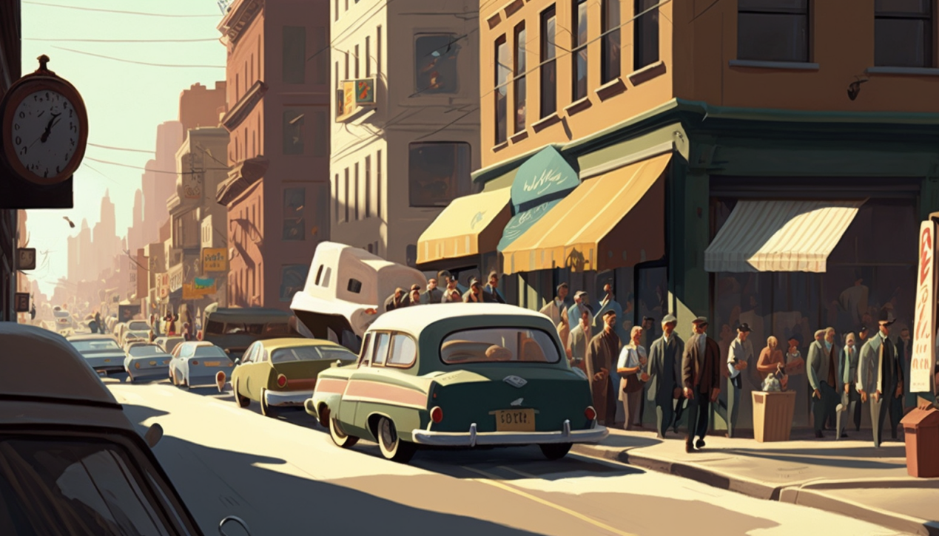

As she walked down the street, Lily saw a man, looking sad. Without hesitation, she walked up to him and held out her flower. "Here," she said softly. "Take this flower. It will make you feel better."

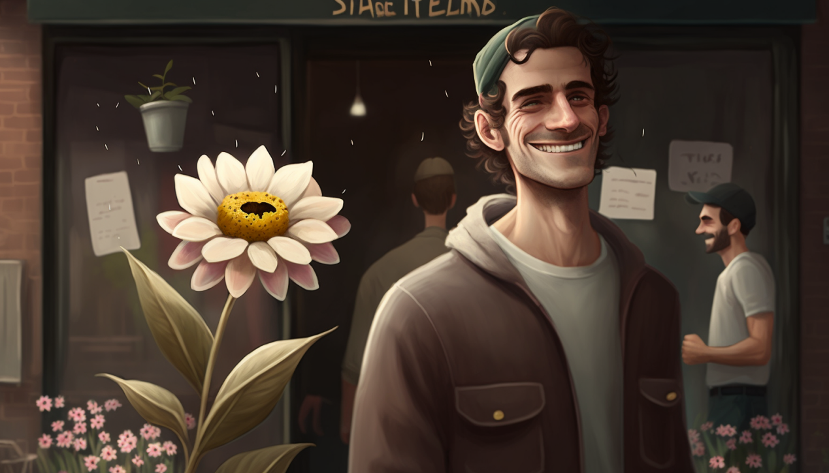

The man looked up at Lily and smiled. "Thank you, little one," he said. "This flower is beautiful. It's just what I needed today."

Lily smiled back at him, feeling a warm feeling in her chest.

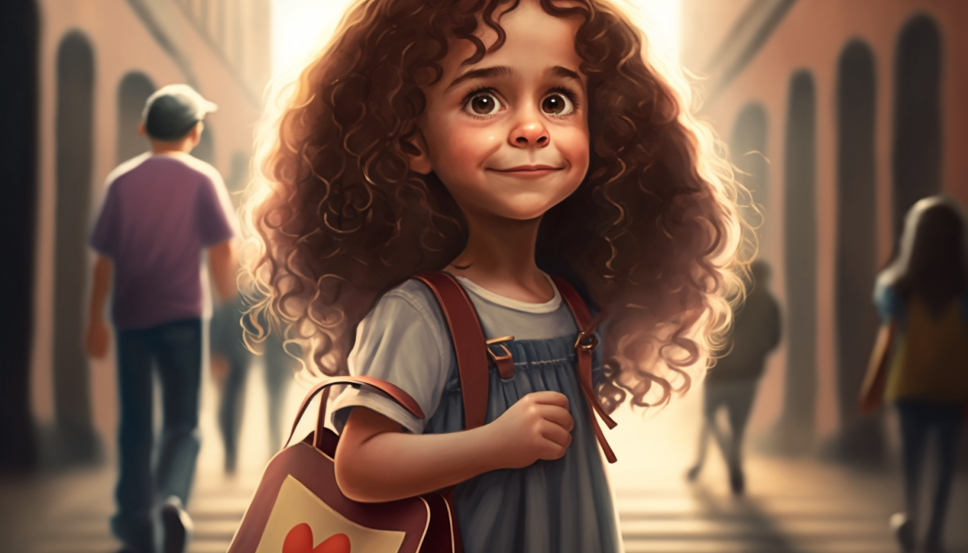

She had finally found someone to give her flower to, and it had made him happy.

As Lily walked back to the orphanage, she was happy. She didn't need a family to be happy. All she needed was to make someone else happy.

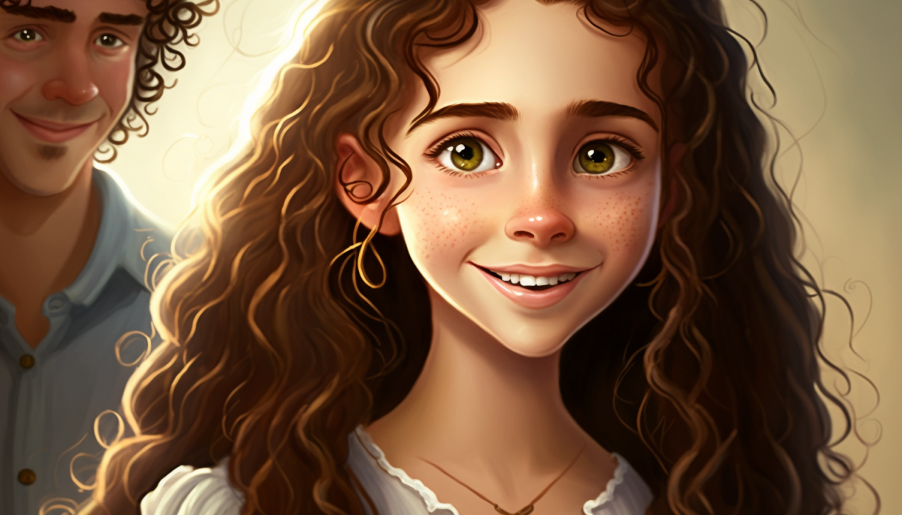

Years went by, and Lily grew up. She left the orphanage and started a family . But she never forgot about her flower. Lily's flower-giving became a tradition among her family and friends.

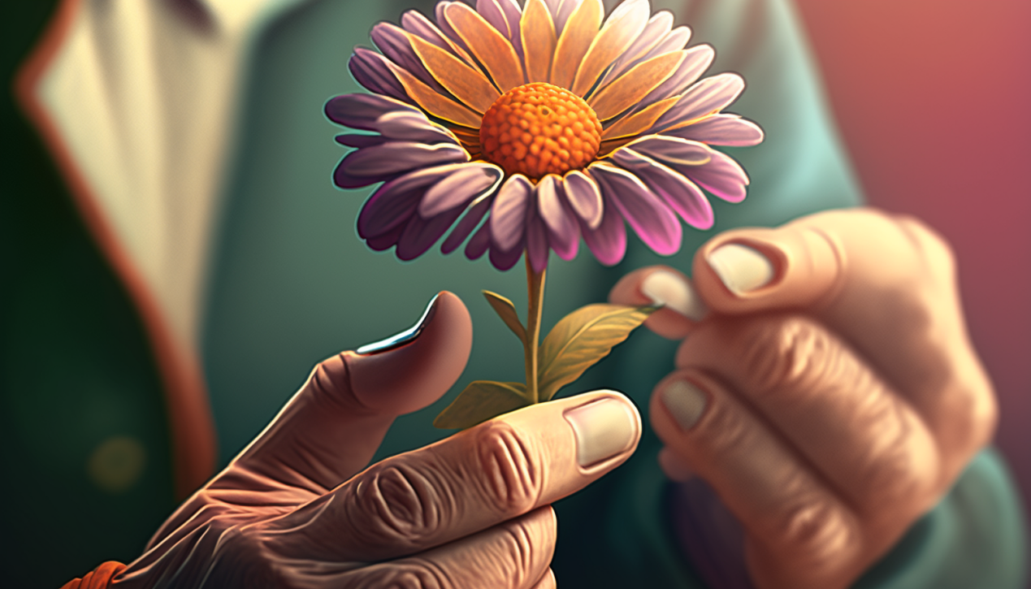

And in a small way, Lily's flower-giving had brought a little bit of love and joy to the world, reminding everyone who received a flower that they were loved and cherished. And in that way, Lily's simple act of kindness had changed the world, one flower at a time.